Ford MUSTANG MACH 1– EUROPEAN Specifications

PERFORMANCE AND ECONOMY

 |  |  | Fuel consumption  l/100 km WLTP | Performance
Engine | Power  (PS) | CO₂  (g/km WLTP) | Overall | Max speed km/h (mph) | 0-100 km/h  0-62 mph  (sec)
5.0-litre V8 fastback  (6-speed manual) | 460 | 284 | 12.4 | 267 (166) | 4.8
5.0-litre V8 fastback  (10-speed automatic) | 460 | 270 | 11.7 | 249 (155) | 4.4

BODY

Construction | Unitised welded steel body, aluminium bonnet and front wings
Aerodynamics | Two-piece upper and lower grille, optimised front splitter, rear diffuser, elongated undertray and single deck rear spoiler
Body Styles | Fastback; left-hand and right-hand drive
Exterior colour options | Fighter Jet Grey with Satin Black and Reflective Orange Stripe  Iconic Silver, Shadow Black or Oxford White with Satin Black and Red Stripe  Velocity Blue, Twister Orange, Race Red or Grabber Yellow with Satin Black and White Stripe
Final assembly location | Flat Rock, Michigan, USA

ENGINE

Configuration | Aluminium block and heads
Intake | Shelby GT350 induction system, composite shell-welded with runner pack and charge motion control valves, 87 mm throttle body
Exhaust | Stainless steel tubular manifold, bespoke-tuned Active Valve Performance Exhaust system, 4.5-inch quad pipes with chrome tips
Valvetrain | DOHC, four valves per cylinder, twin independent variable camshaft timing
Valve diameter/lift (mm) | Intake 37.7 /13  Exhaust 32.0 /13
Pistons | Cast aluminium
Connecting rods | Forged steel
Crankshaft | Forged steel cross-plane
Ignition | Distributor-less with coil-on-plug
Bore x stroke (mm) | 93.0 x 92.7
Displacement (cc) | 5038
Compression ratio | 12.0:1
Engine control system | PCM with unique software calibration
Power | 460 PS (338 kW) @ 7250 rpm
Torque | 529 Nm @ 4900 rpm
Fuel capacity (litre) | 61
Fuel delivery | Dual-injection system featuring low-pressure port fuel injection and high-pressure direct injection
Oil system | 9.5-litre capacity, Shelby GT350 air-to-oil cooler, bespoke engine oil filter adaptor

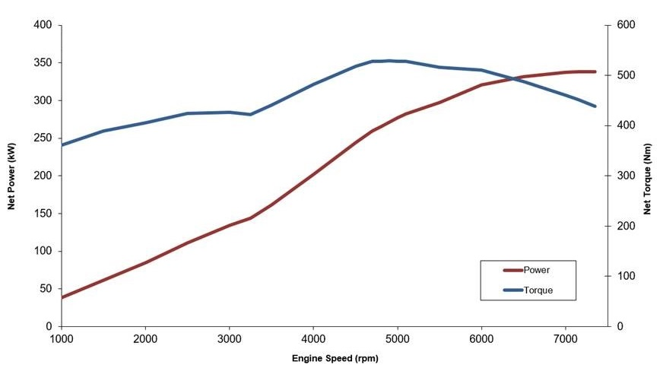

DRIVETRAIN

Layout | Rear-wheel drive with limited-slip differential, transmission oil cooler and rear axle cooler
Gearbox | TREMEC TR-3160 six-speed manual, short-throw shift, rev-matching  10-speed automatic, optimised torque converter and unique software calibration. Secondary air-to-oil cooler
Clutch | Twin-disc (manual transmission only)

TRANSMISSION

Standard | TREMEC TR-3160 six-speed manual | Ford 10-speed automatic
First | 3.25 | 4.70
Second | 2.23 | 2.99
Third | 1.61 | 2.15
Fourth | 1.24 | 1.77
Fifth | 1.00 | 1.52
Sixth | 0.63 | 1.28
Seventh | N/A | 1.00
Eighth | N/A | 0.85
Ninth | N/A | 0.69
Tenth | N/A | 0.64
Final drive | 3.55 | 3.55

SUSPENSION

Front | MagneRide® DampingSystem, double-ball-joint independent MacPherson strut, inverted Monotube dampers with bespoke springs,33.3 mm tubular stabiliser and front subframe bushings specifications
Rear | MagneRide® DampingSystem,integral-link independent with bespoke springs and24.0 mm solid stabiliser bar specifications.Mono-tube dampers

BRAKES

Type | Four-wheel power disc brakes with four-sensor, four-channel anti-lock braking system and AdvanceTrac electronic stability control.Optimised brake booster and cooling via undertray fins
Front | 380 mm x 34 mm vented discs, Brembo six-piston 36 mm fixed aluminium callipers
Rear | 330 mm x 25 mm vented discs, Brembo single-piston 45 mm floating iron callipers, integral parking brake

STEERING

Type | Selectable electric power-assisted steering with rack-and-pinion gear, unique software tuning
Ratio | 16:1
Turning circle, kerb-to-kerb | 12.2 m

WHEELS AND TYRES

5.0-litre V8 | Front: Michelin Pilot Sport 4 255/40 R19 tyres, 19-inch x 9.5-inch aluminium wheels | Rear: Michelin Pilot Sport 4 275/40 R19 tyres, 19-inch x 10-inch aluminium wheels

DIMENSIONS

EXTERIOR
Wheelbase (mm) | 2720
Overall length (mm) | 4797
Overall width excluding mirrors (mm) | 1916
Overall width including mirrors (RHD) (mm) | 2081 (2097)
Overall width mirrors folded (RHD) (mm) | 1957 (1985)
Overall height (max) (mm) | 1382
Track, front/rear (mm) | 1594/1646
Minimum ground clearance (kerb) (mm) | 120
INTERIOR
Seating capacity | Four
Front headroom (mm) | 955
Front legroom – maximum (mm) | 1146
Front shoulder room (mm) | 1430
Front hip room (mm) | 1395
Rear headroom (mm) | 884
Rear legroom (mm) | 737
Rear shoulder room (mm) | 1327
Rear hip room (mm) | 1203
Loading Width Between Wheelhouses (mm) | 1010
Load Opening Width at floor (mm) | 640
Liftover Height (kerb) (mm) | 761
Cargo volume (litre) ‡ | 408

‡Measured in accordance with ISO 3832. Information provided for base vehicle, except where specified. Dimensions may vary dependent on the model and equipment fitted.

WEIGHTS

 | Kerb weight (kg)# | Gross Vehicle Mass(kg) | Maximum Loading Weight (kg)
5.0-litre V8 fastback (6-speed manual) | 1839 | 2114 | 275
5.0-litre V8 fastback (10-speed automatic) | 1861 | 2150 | 289

# Represents the lightest kerbweight assuming driver at 75 kg, full fluid levels and 90per cent fuel levels, subject to manufacturing tolerances and options, etc., fitted.

